**Student Name: Raj Kumar Bhukya**

**Student Number: W9598301**

**Module Leader: Julien Cordry**

**Module Code: CIS4034-N**

**Supporting Document for ICA**

**Submission Date: 13/12/2023**

**Table of Contents**

1 . App and Target Audience 4

1.1 Activity Flow Diagram 5

2 . Structure and operations of the application 6

2.1Login Page 7

2.2Registration Page 7

2.3Home Page 8

2.4Product Details 8

2.5Payment Page 9

2.6Order Successful Page 10

3 . Library Used 10

4. Software Design Decisions 11

5. Legal issues 11

5.1 General Data Protection Regulation 11

6 . Social and Ethical Issues 11

7. Development Strategy 12

8. Professional Tools 13

9 . Application Usage and Screenshots. 14

10. References 16

# App and Target Audience

## In today's fast-paced digital landscape, embracing technology is crucial. The surge in online apparel shopping, facilitated by fashion store mobile applications, caters to a diverse audience seeking convenience. Users, ranging from teens to adults, can easily register, browse products, and enjoy a seamless shopping experience. With features like Wishlist and personalized recommendations, this application enhances user satisfaction. A valuable marketing tool for fashion stores, it boosts visibility and brand loyalty, making mobile fashion shopping a practical and enjoyable endeavor.

## Activity Flow Diagram

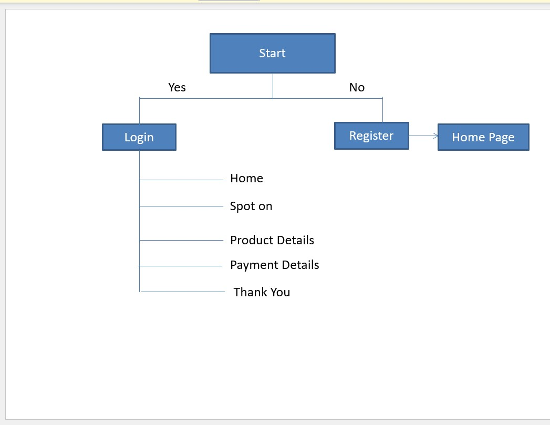

# Structure and operations of the application

## Login Page

The login page will let the user enter the app to do the shopping. The user will be able to login if they are already registered, or they will be asked to sign up if not registered previously. The user can register by clicking on the sign-up button which is available at the bottom.

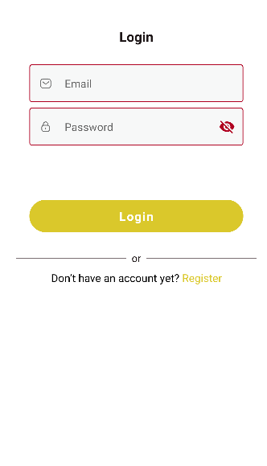

**Code for login page**

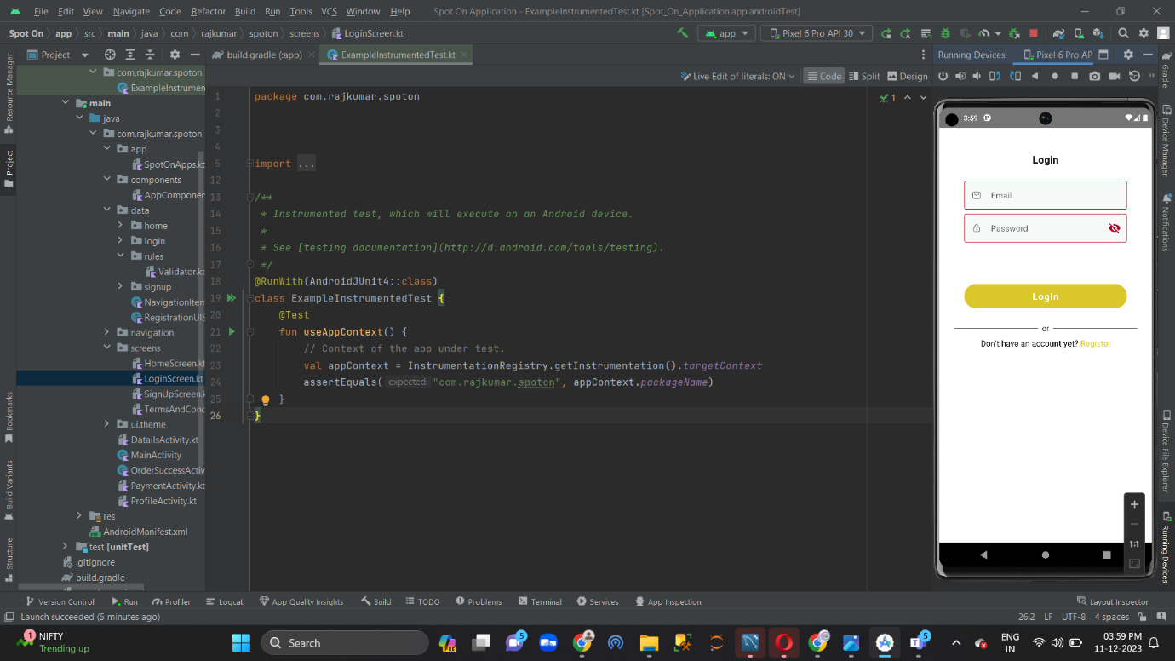

## Registration Page

The registration page is used to get registered with the application. The user needs to provide the basic information like name, email, and mobile number to get started with. Once the registration is done, the next step is to login to the application with the email id and password used at the time of registration.

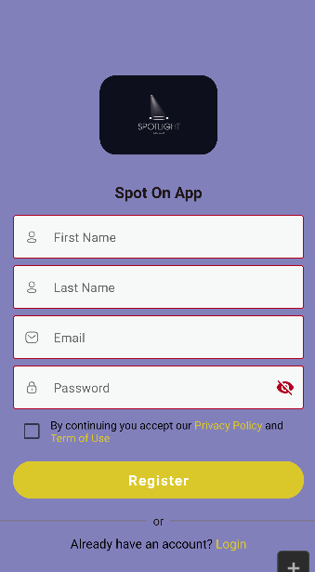

**Code for Register page**

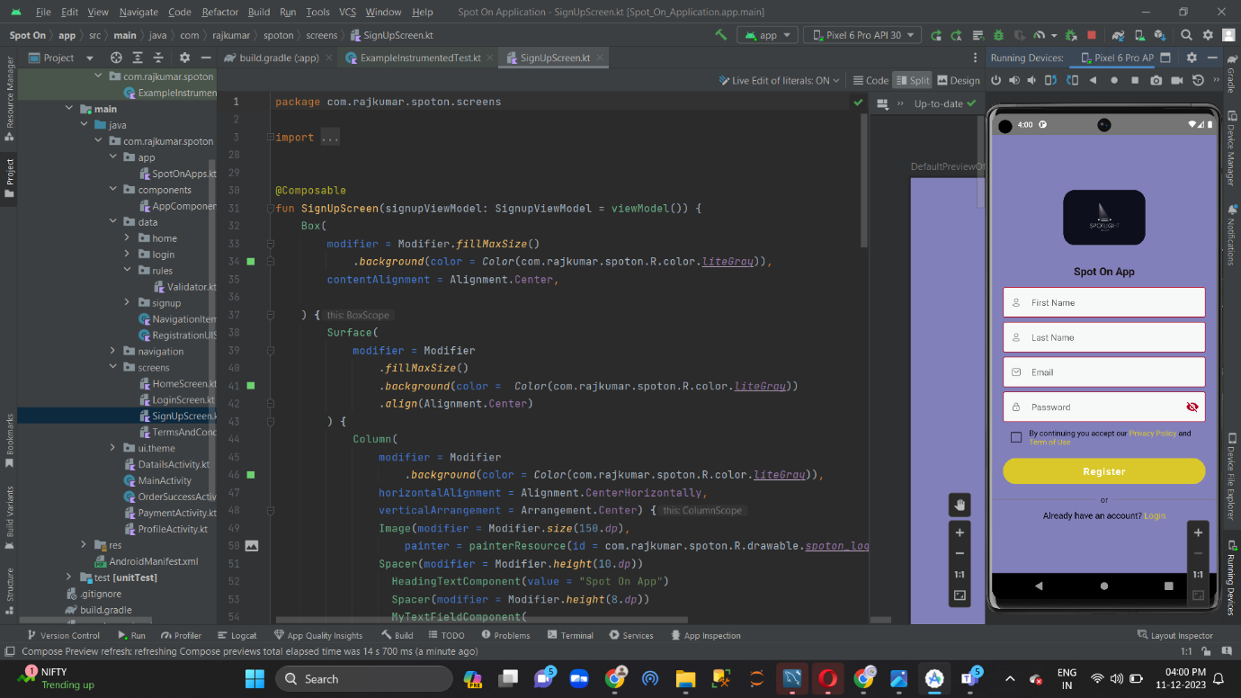

## Home Page

After a successful login, the following step is to view the home page. After being taken to the main page, the user can browse a selection of well-liked products, utilize the search field to look up specific products, and use the bottom navigation bar.

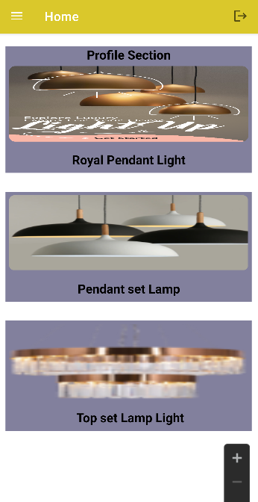

**Code for Home page**

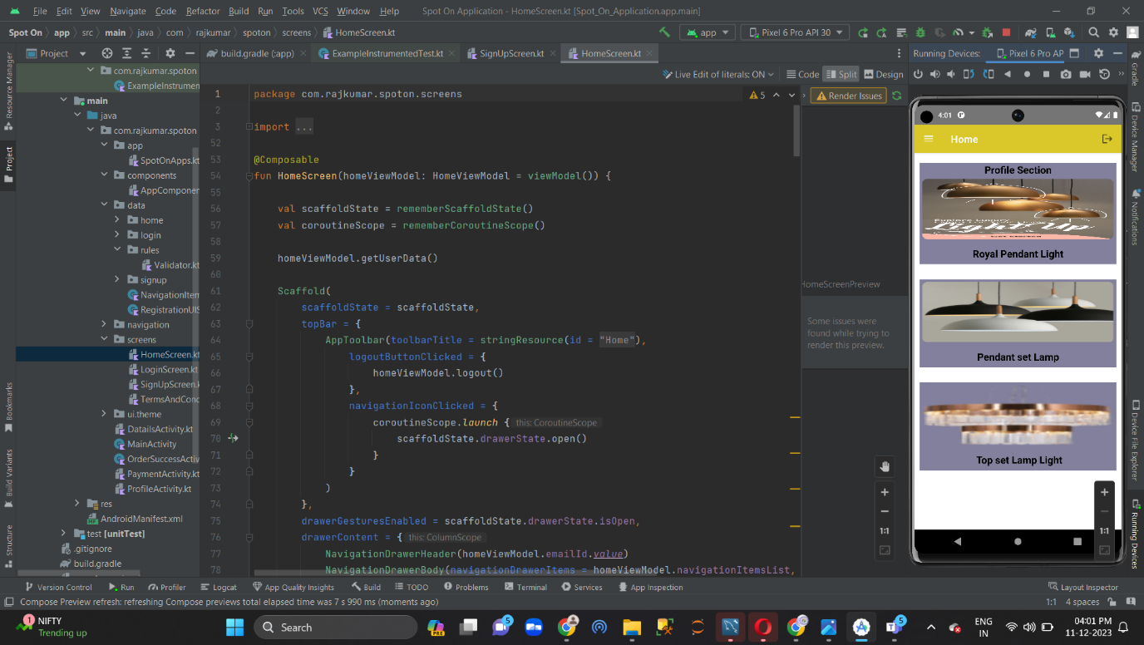

## Product Details

The product details can be obtained by clicking on a product which will redirect to the product detail page. The user will be able to see the product in detail and can decide on purchasing the item. The user also can make use of the Wishlist button provided in the same page to add the product to the Wishlist for later reference.

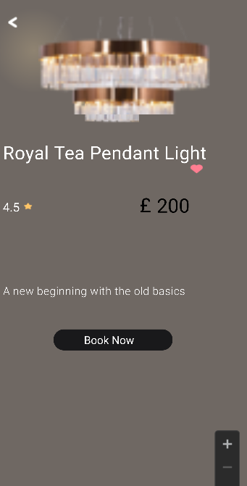

**Code for product details**

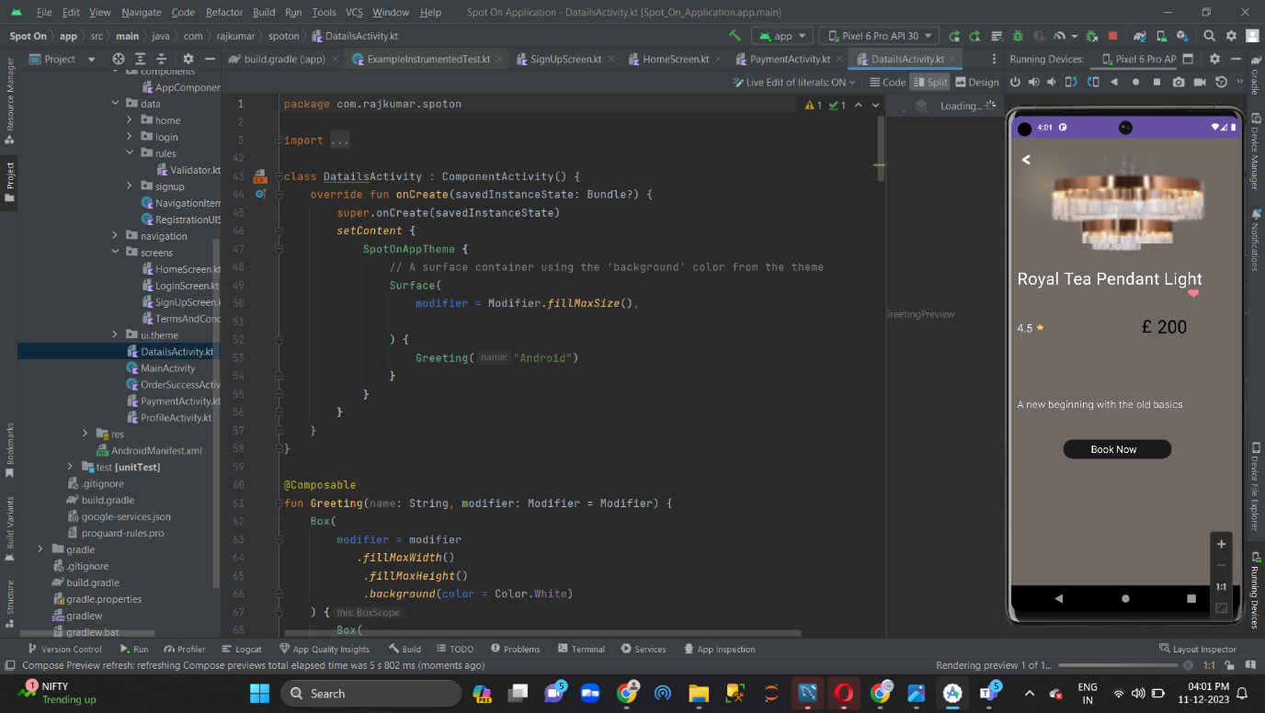

## Payment Page

The payment page section is used to enter or edit user’s information .proceed button is navigated to the booking successful page

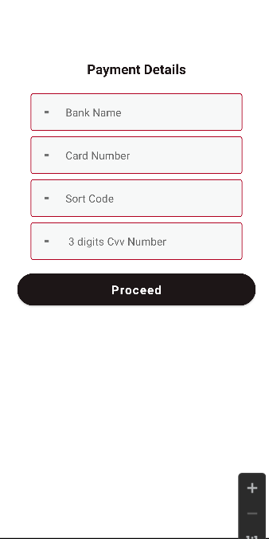

**Code for payment page**

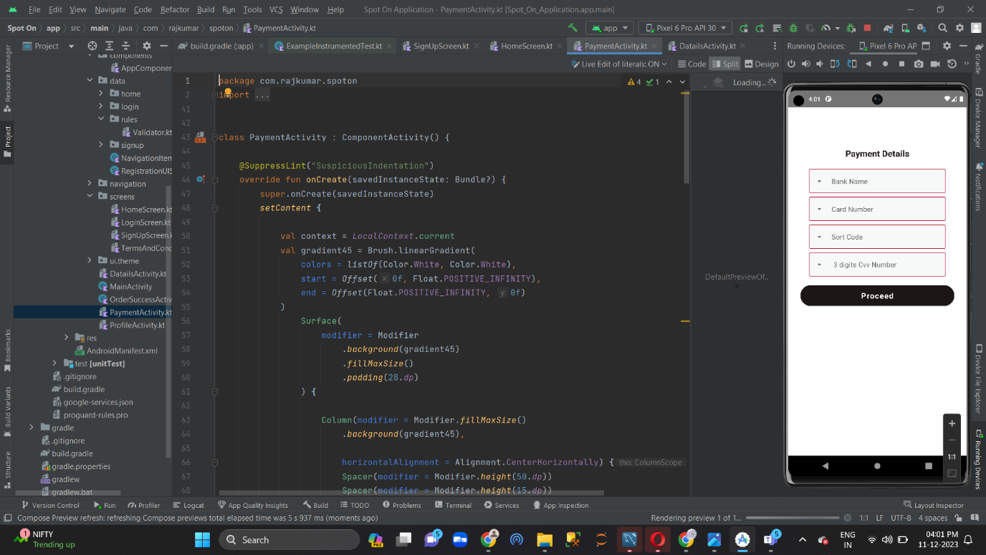

## Order Successful Page

In the home page bottom navigation there will be a profile icon. By clicking on the icon user will be redirected to the profile page of the application. In the profile page user can add the profile photo and can edit the name and the mobile number.

Once the interested products are selected and ordered successfully, the user will see a page called ‘order successful page’. Here, they will see the thank you and order placed confirmation message. The user can now go back and continue browsing products or do shopping.



**Code for booking successful page**

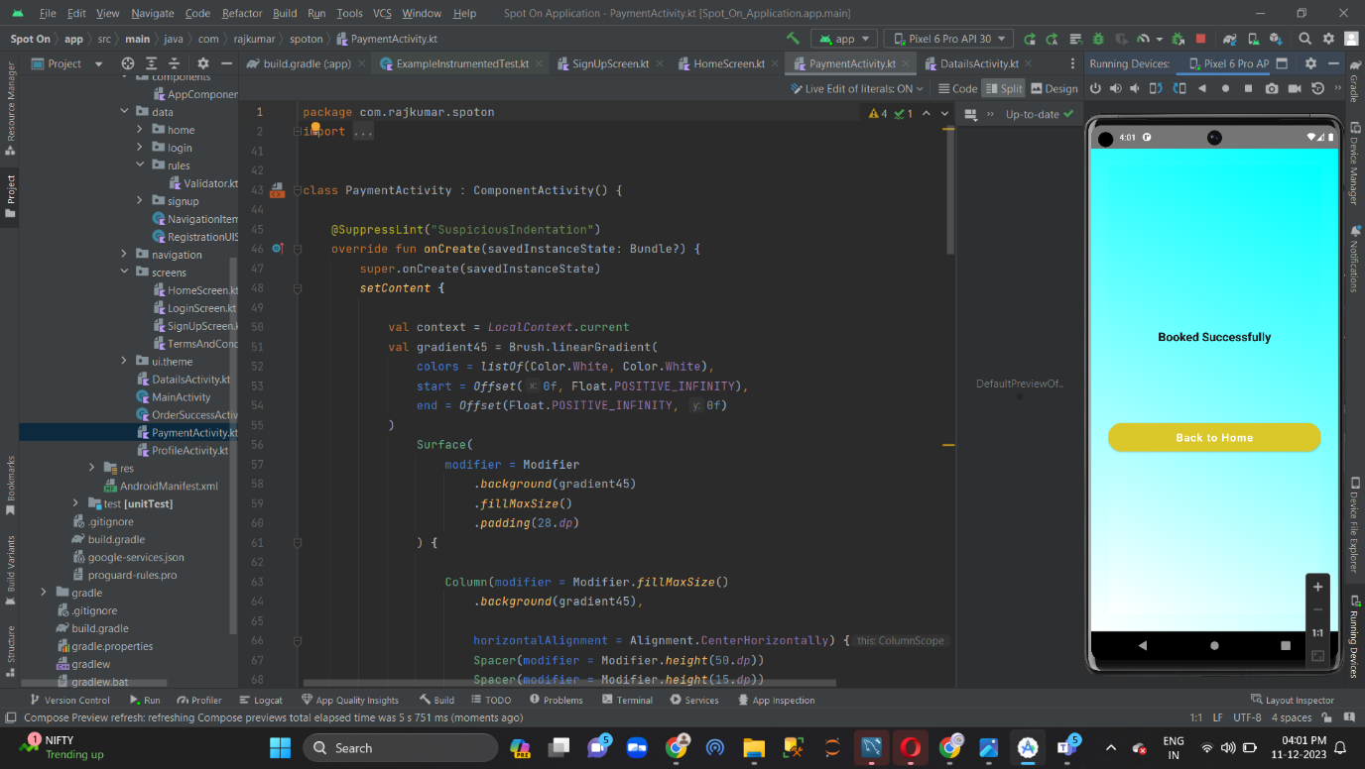

# Library Used

As part of the project, I used various libraries to successfully develop a mobile application. The libraries I used are App Compat, a library that enables Android app compatibility with older versions. Firebase offers a suite of services for app development. Material is a design language for Android UIs. Constraint Layout is a flexible layout manager for Android.

# Software Design Decisions

Technological adoption is essential in today's fast-paced digital world. An array of convenience-seeking consumers are served by the rise in online clothing purchasing made possible by fashion retailer mobile applications. Visitors of all ages can effortlessly register, peruse merchandise, and take pleasure in an effortless shopping journey. This program improves customer pleasure with features like Wishlist as well as customized recommendations. Enhancing brand loyalty and visibility, mobile fashion shopping is a fun and useful activity. It is a fantastic marketing tool for fashion stores. Data integrity is guaranteed by ACID compliance, and its extensibility helps the application adapt to changing requirements.

Additionally, the growing number of various screen sizes and devices justifies the need of a responsive web design approach. This choice improves accessibility and user satisfaction by placing a higher priority on a consistent user experience across platforms.

All these choices in software design work together to provide a system that is user-friendly, scalable, and interconnected. Each component is thoughtfully chosen to create an architecture that is in line with the project's goals and flexible enough to deal with upcoming technological developments.

# Legal issues

## General Data Protection Regulation

The latest GDPR is a law introduced by the European Union in May 2018. It aims to create a structure for safeguarding the personal data of EU citizens, regardless of where the data is stored or processed. Any organization that gathers, utilizes, or manages the personal data of EU citizens is subject to the GDPR (Zaeem *et al.,* 2020). The regulation provides individuals with more authority over their personal data and allows them to access, modify, or delete it. Companies that breach GDPR may face serious consequences, such as substantial fines and legal proceedings. The implementation of GDPR has had a significant effect on businesses, as they are now required to be more transparent and accountable in their handling of personal data.

**5.2. Terms of services & privacy policy**

Terms of service outline the rules and regulations that govern the use of a mobile application. It typically covers aspects such as user behavior, content, and access to the service, as well as any restrictions or limitations. On the other hand, privacy policy is a statement that outlines the types of personal data that an application collects, how it is collected, how it is used and shared, and the measures taken to protect user privacy (Andow *et al.,* 2019). It is an important legal document that helps build trust between users and the application owners.

1. Social and Ethical Issues

During the registration and login process, the user might be required to provide personal information such as their name, last name, and mobile number. Rest assured that this data is kept private and not shared (Shi *et al.,* 2020). To ensure safety, token-based APIs are used, and passwords are encrypted. To update profile pictures, the user may need to allow the application to access their gallery. Additionally, the location of the user may be tracked using their current location. However, permissions for these actions are provided and listed below.

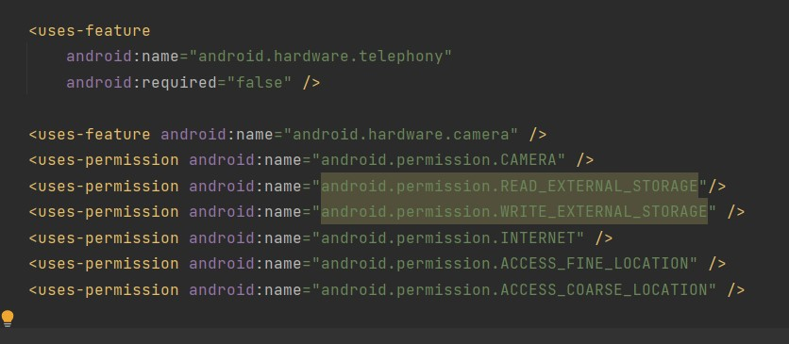

1. Development Strategy

I have used Trello using Kanban Method which is type of Agile Methodology to track my Project Workflow. The Phases of the Project are listed below.

**Phase 1**

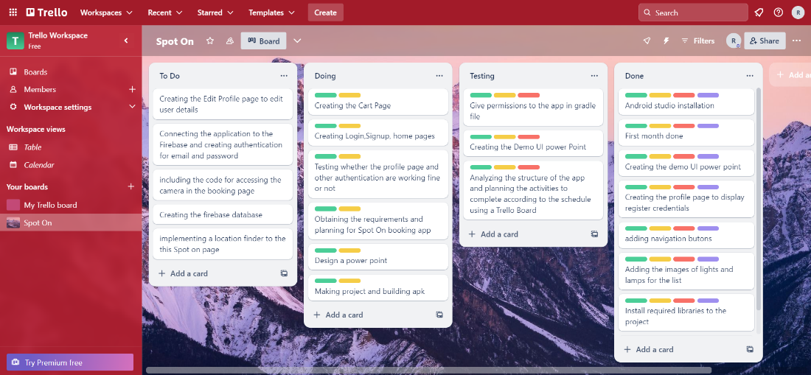

**Phase 2**

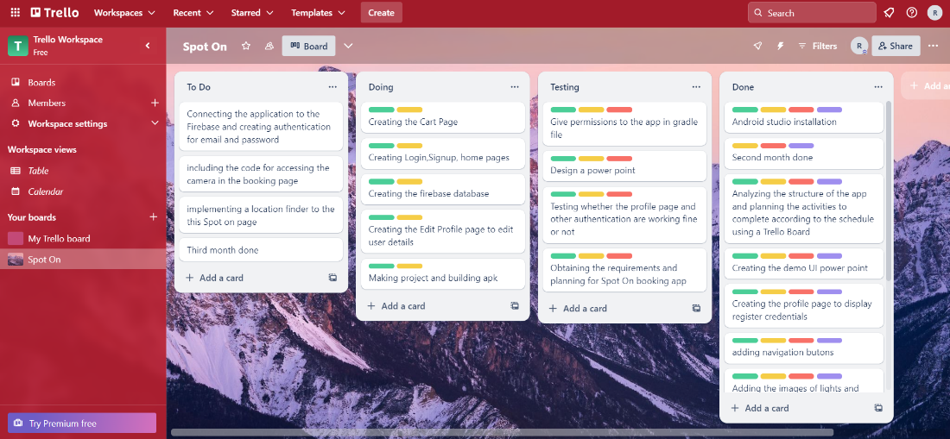

**Phase 3**

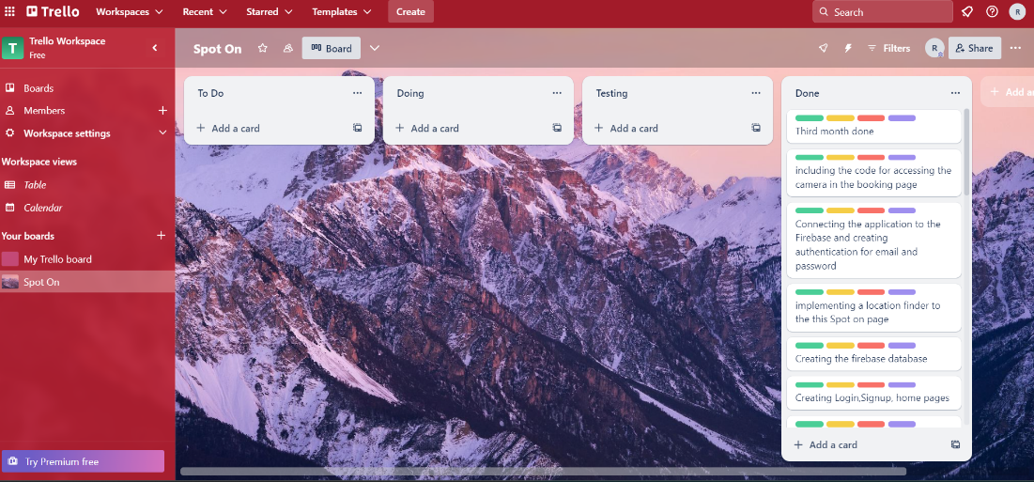

# Professional Tools

Agile, AVD Manager, GitHub, and Android Studio - Bumble Bee version 2021.1.1 are all important to consider and applying to use.

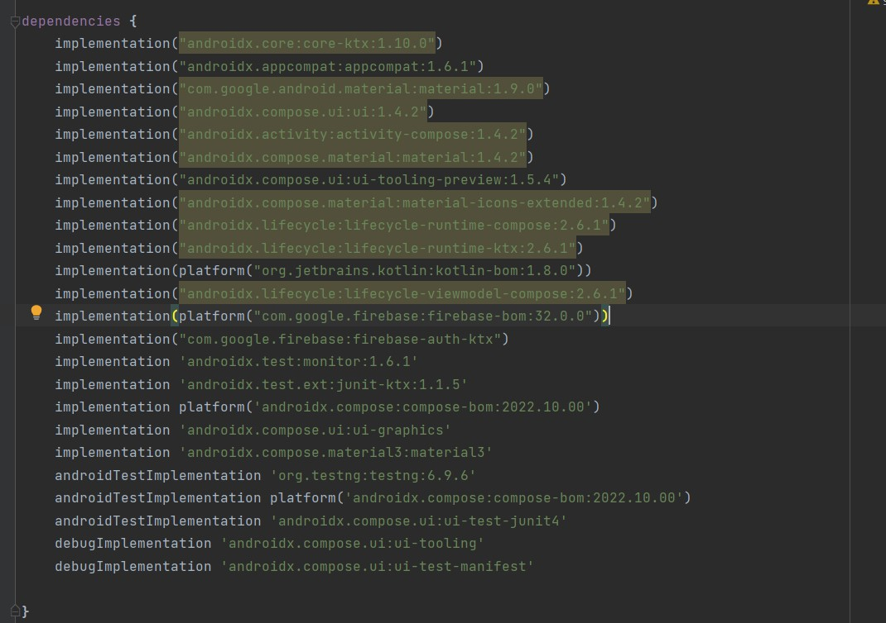

# References

Chattell, A., 2016. *Creating value in the digital era: Achieving success through insight, imagination and innovation*. Springer.

Elizabeth Lloyd, A., YK Chan, R., SC Yip, L. and Chan, A., 2014. Time buying and time saving: effects on service convenience and the shopping experience at the mall. *Journal of services Marketing*, *28*(1), pp.36-49.

[**https://developer.android.com/kotlin?gclid=CjwKCAiApuCrBhAuEiwA8VJ6JjlCrd5vgkDbkKO8im0S1tfUWLgYBW30xcK_ffJRCOp55DmRf5Js3RoC8zsQAvD_BwE**](https://developer.android.com/kotlin?gclid=CjwKCAiApuCrBhAuEiwA8VJ6JjlCrd5vgkDbkKO8im0S1tfUWLgYBW30xcK_ffJRCOp55DmRf5Js3RoC8zsQAvD_BwE)

<https://firebase.google.com/docs/database/web/structure-data#:~:text=easy%20as%20possible.-,How%20data%20is%20structured%3A%20it's%20a%20JSON%20tree,are%20no%20tables%20or%20records>.